Sandhill Foundation Stage - EYFS Map Cycle 1
 | Autumn 1 | Autumn 2 | Spring 1 | Spring 2 | Summer 1 | Summer 2
Text Driver |  | 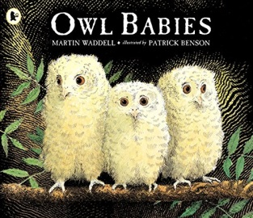 | 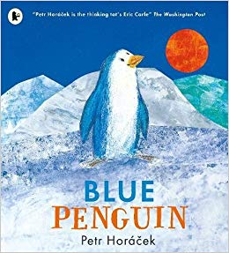 | 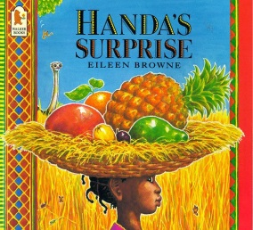 | 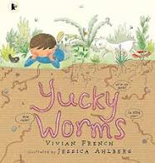 | 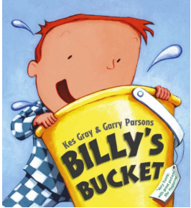
 | Books based on children’s own interests (Children’s Favourite Books) | Owl Babies | Blue Penguin | Handa’s Surprise | Yucky Worms | Billy’s Bucket.
Personal, Social and Emotional Development | JIGSAW- Being Me In The World Getting to know you  Settling in to a new class  Creating class rules  Becoming familiar with routines and expectations | JIGSAW- Celebrating Differences Talking in a familiar group about their own family  Exploring emotions and feelings – how do we show emotions?  Positive relationships with adults and other children | JIGSAW- Dreams and Goals Choices and actions of characters  Discussing when certain behaviour is not acceptable and the consequences  Toys that are special to us  Importance of saying sorry | JIGSAW- Healthy Me  Exploring friendships and what makes us special  Discuss sensitivity to others needs and feelings | JIGSAW- Relationships  Positive relationships with adults and other children  Talk about their own ideas | JIGSAW- Changing Me  Positive relationships with adults and other children  Discussing when certain behaviour is not acceptable and the consequences  Feelings and emotions of the different characters  Importance of team work
Communication & Language | Ask and answer questions about what they have learned  Talk about their own experiences  Following instructions | Listen to the text driver and other linked stories  Ask and answer questions about what they have learned  Talk about their own family and celebrations  Following instructions | Listen to the text driver and other linked stories  Ask and answer questions about what they have learned  Talk about penguins  Following instructions | Listen to the text driver and other linked stories  Ask and answer questions about what they have learned  Talk about wild animals  Following instructions | Listen to the text driver and other linked stories  Ask and answer questions about what they have learned  Talk about different minibeasts  Talk about how things change over time  Following instructions | Listen to the text driver and other linked stories  Ask and answer questions about what they have learned  Talk about what they would put in their bucket
Physical Development | Funky fingers/ pencil grip activities  Weekly PE session – developing spatial awareness, good control and co-ordination in large and small movements  Moving in different ways  Managing their own basic hygiene | Funky fingers/ pencil grip activities  Weekly PE session – developing spatial awareness, good control and co-ordination in large and small movements  Moving in different ways  Managing their own basic hygiene | Funky fingers/ pencil grip activities  Weekly PE session  Dressing/undressing for PE independently  Developing spatial awareness, good control and co-ordination in large and small movements  Moving in different ways – like a penguin  Managing their own basic hygiene  Discuss healthy choices for breakfast | Funky fingers/ pencil grip activities  Handwriting  Weekly PE session Dressing/undressing for PE independently  Developing spatial awareness, good control and co-ordination in large and small movements  Moving in different ways  Exploring African dance  Managing their own basic hygiene  Discuss ways of keeping healthy and safe | Funky fingers/ pencil grip activities  Handwriting  Weekly PE session Dressing/undressing for PE independently  Developing spatial awareness, good control and co-ordination in large and small movements  Moving in different ways  Managing their own basic hygiene  Discuss ways of keeping healthy and safe | Funky fingers/ pencil grip activities  Handwriting  Weekly PE session Dressing/undressing for PE independently  Developing spatial awareness, good control and co-ordination in large and small movements  Team games  Preparing for Sports Day  Managing their own basic hygiene Discuss ways of keeping healthy and safe
Literacy | Daily RWInc session  Name Writing  Distinguishing between marks on a paper. | Daily RWInc session  Name Writing  Reading and writing simple words  Story sequencing and retelling | Daily RWInc session  Reading and writing captions and labels  Story sequencing and retelling | Daily RWInc session  Reading and writing captions and labels  Reading and writing simple sentences  Story sequencing and retelling | Daily RWInc session  Reading and writing captions and labels  Reading and writing simple sentences  Story sequencing and retelling  Read and write some common irregular words | Daily RWInc session  Reading and writing captions and labels  Reading and writing simple sentences  Story sequencing and retelling.  Read and write some common irregular words
Maths | Counting  Ordering numbers  matching numbers to quantity  2d shapes  Position  Height – tall and short  Comparing 2 sets of objects and combining 2 sets | Adding two amounts by counting all of them  Length  Finding one more/ one less  3D shapes  Counting  Pattern | Counting  Finding one more/ one less  Addition  Subtracting  Length  Weight  Doubling numbers  Pattern | Counting and ordering numbers to 20  Reading and writing numbers  Subtraction – counting back  Time  Halving  Money  Pattern | Addition - counting on  Solving problems involving addition and subtraction  Sharing  3D Shape  Estimating and counting | Pattern and Symmetry  Number problems involving adding and subtracting  Sharing items out equally  Doubling number (money)  Counting (in 2’s, 5’s and 10’s)  Length  (using rulers)
Understanding the World | Discussion about themselves – discuss similarities and differences between themselves and others  Using cameras to take photographs to take selfies and pictures of each other  Explore devices such as laptop, mobile phone in the role play area | Discussing past and present events in their own lives and in the lives of others - Christmas  Diwali  Explore devices such as laptop, mobile phone in the role play area | Talk about their immediate environment  Using Ipad or computer to create a picture  Using IPads and laptops to research penguin and other sea creatures  To compare Antarctic to Great Houghton | Exploring wild animals and talking about their appearance and what they are like  Discussing likes and dislikes-its ok not to like the same things -sensitivity  Talk about their immediate environment and compare Kenya with Great Houghton  Using Ipad or computer to create a picture | Exploring minibeasts and how things change  Making observations  Develop good mouse control on the laptop  Use Ipad/laptops to complete a simple program | Exploring sea creatures and talking about their appearance and what they are like  Using Ipad or computer to create a picture  Use Ipad/laptops to complete a simple program
Expressive Art & Design | Singing familiar songs and rhymes.  Using a range of media o create pictures of themselves  Using imagination in role play area and provision areas | Singing familiar songs and rhymes  Christmas Performance  Exploring forest sounds Exploring instruments | Singing familiar songs and rhymes  Colour mixing- painting pictures of characters  Making a penguin model | Singing familiar songs and rhymes  Colour mixing- painting pictures of wild animals and fruit  Printing with fruit and vegetables | Singing familiar songs and rhymes  They use and explore a variety of materials to create a class bug hotel | Singing familiar songs and rhymes Colour mixing- painting pictures of sea creatures  Create their own bucket using their original ideas, thinking about uses and purposes
Role Play | School
Parent/Carers | Christmas  FS1 and FS2 Stay and Play Session.  FS2 Parents Evening |  | FS1 and FS2 Stay and Play Session.  FS2 parents evening |  | Sports Day.  Transition Meetings.  End of year reports  Parents open afternoon
Trips/Visits |  |  | Visit to The Deep

