Sandhill Primary School

Personal Development Programme 2023-24
The Sandhill curriculum extends beyond the academic, technical, or vocational. Our curriculum holds the unique child at the centre of all that we do and supports pupils to develop in many diverse aspects of life. Our whole ethos is built around good relationships at all levels, and we ensure that from the moment a child enters Sandhill, we create an unbroken line of quality and nurture. We care and we hope it shows to all who come into contact with our team.

Intent
Our intention is to provide a rich range of personal development opportunities that will enable each child to: celebrate their uniqueness, feel valued and loved, make informed choices, be resilient and be equipped to face their life journey ahead. No matter what the circumstances or challenges they face, we hold on to every child and don’t let go until it is time for them to take their next step on their journey. Through our personal development curriculum, we aim to:
- develop responsible, respectful, and active citizens
- develop and deepen pupils’ understanding of the fundamental British values
- promote equality of opportunity so that all pupils can thrive together
- promote an inclusive environment that meets the needs of all pupils
- develop pupils’ character
- develop pupils’ confidence, resilience, and knowledge so that they can keep themselves mentally healthy
- enable pupils to recognise online and offline risks to their well-being
- enable pupils to recognise the dangers of inappropriate use of mobile technology and social media
- develop pupils’ understanding of how to keep physically healthy, eat healthily and maintain an active lifestyle
- develop pupils’ age-appropriate understanding of healthy relationships through appropriate relationships and sex education
- support readiness for the next phase of education, so that pupils are equipped to make the transition successfully

Woven throughout the Sandhill curriculum are opportunities for children to develop Spiritually, Morally, Socially and Culturally, gain a deeper understanding of the British and our school values and share in our school vision through understanding what drives us to be the people that make Sandhill such an inspiring and wonderful place.

Spiritual, Moral, Social and Cultural Development:
Spiritual  - ability to be reflective about their own beliefs (religious or otherwise) and perspective on life  - knowledge of, and respect for, different people’s faiths, feelings and values  - sense of enjoyment and fascination in learning about themselves, others and the world around them  - use of imagination and creativity in their learning  - willingness to reflect on their experiences | Social  - use of a range of social skills in different contexts, for example working and socialising with other pupils, including those from different religious, ethnic and socio-economic backgrounds  - willingness to participate in a variety of communities and social settings, including by volunteering, cooperating well with others and being able to resolve conflicts effectively  - acceptance of and engagement with the fundamental British values of democracy, the rule of law, individual liberty and mutual respect and tolerance of those with different faiths and beliefs. They will develop and demonstrate skills and attitudes that will allow them to participate fully in and contribute positively to life in modern Britain
Moral  - ability to recognise the difference between right and wrong and to readily apply this understanding in their own lives, and to recognise legal boundaries and, in doing so, respect the civil and criminal law of England  - understanding of the consequences of their behaviour and actions  - interest in investigating and offering reasoned views about moral and ethical issues and ability to understand and appreciate the viewpoints of others on these issues | Cultural  - understanding and appreciation of the wide range of cultural influences that have shaped their own heritage and that of others  - understanding and appreciation of the range of different cultures in the school and further afield as an essential element of their preparation for life in modern Britain  - ability to recognise, and value, the things we share in common across cultural, religious, ethnic, and socio-economic communities  - knowledge of Britain’s democratic parliamentary system and its central role in shaping our history and values, and in continuing to develop Britain  - willingness to participate in and respond positively to artistic, musical, sporting, and cultural opportunities  - interest in exploring, improving understanding of and showing respect for different faiths and cultural diversity and the extent to which they understand, accept, respect and celebrate diversity. This is shown by their respect and attitudes towards different religious, ethnic, and socio-economic groups in the local, national and global communities

Our School Values:
Sandhill’s 4 R’s
Ready – At Sandhill, we develop pupils understanding around what ‘being ready’ means. Pupils understand the importance and significance of education through the National and Sandhill’s wider personal development curriculum and know that to ‘be ready’ means to direct and maintain a focus on their daily activities so that they may find success and further develop themselves academically and on a personal level. When we are ready at Sandhill, we are: prepared for learning with all of our equipment ready, trying our best, employing a positive attitude in all we do, quiet at appropriate times and using our best listening skills.
Responsible – Through our curriculum, we develop children’s understanding of responsibility and its importance through school and in wider life. We develop children to be responsible members of our school and wider community through a variety of opportunities and challenges. When we are responsible at Sandhill, we are: following the instruction of adults, taking ownership of our own learning and personal development, taking ownership of our own behaviour and understanding how this affect others, employing a positive attitude in all we do.
Respectful – Respect is a huge part of everything that we do at Sandhill. It underpins the relationships that we form and maintain across school and drives our social interactions each day. Pupils develop a deep understanding of respect throughout their life at Sandhill and understand it’s importance in our school, local and the wider community of Modern Britain. When we are respectful at Sandhill, we are: showing respect to other pupils in school and understanding the importance of mutual respect, showing respect to staff and those who care about us, deepening our own self-respect and realising our self-worth and respecting the differing environments that we find ourselves in both in and out of school.
Resilient – “Hardships often prepare ordinary people for an extraordinary destiny” – C. S. Lewis. Resilience is a key personal trait that is keenly developed at Sandhill. We believe that developing resilience and perseverance throughout our curriculum will allow pupils to leave us ready to face any challenges and pursue any opportunities that may cross their path. Children understand the importance of having a growth mindset and the need to persevere to achieve personal and wider success. When we are resilient at Sandhill, we are: being determined when things get tough and never giving up in all aspects of school life, trying new things that may prove challenging at first, encouraging our peers to persevere so that they may share in our success and developing a growth mind set that will allow us to achieve our future dreams and goals.
Additional Values that we explore and promote at Sandhill:
Fundamental British Values:  - Democracy  - The Rule of Law  - Individual Liberty  - Mutual Respect  - Tolerance of Other Faiths and Beliefs | Additional school values stated in our school vision:  - Openness  - Honesty  - Fairness  - Confidence  - Love of Language  - Inquisitiveness

Oracy at Sandhill
At Sandhill, we are extremely keen to develop the spoken language of all pupils so that they are able to meet the varied challenges that life presents. We understand that good language skills share a strong connection with early literacy skills, social skills, behaviour management skills, self-regulation, problem solving and academic achievement. We therefore proudly offer the following strands of personal development for our children:
Talk for Learning
- Ensuring that our learning environments are language rich and that children are consistently exposed to new vocabulary in order to close the language and word gap for pupils
- Interweave oracy opportunities in all areas of the curriculum so that children have the opportunity to practice the knowledge and skills learned through the oracy curriculum
- Implementation of a specific oracy curriculum where children have the opportunity to develop their confidence, knowledge and articulation of spoken language. An example of our oracy curriculum:
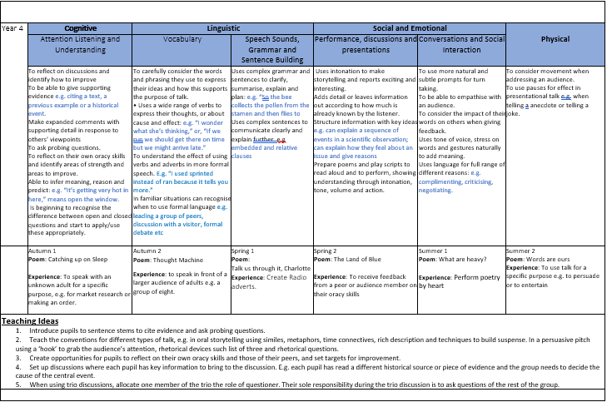
Talk For Life
- Daily morning positive touch greetings for children to start their day on a positive
- Daily time each morning to record their feelings in their Talk for Life journals. This can be through writing or drawing
- Daily time for adults to monitor Talk for Life journals and speak to any children who wish to share something that is worrying them. Some children will also receive daily 1:1 check ins with adults.
Implementation
Personal development of every child at Sandhill is supported through a wide variety of whole school opportunities and experiences alongside individual teaching. A snapshot of some of the ways we implement the personal development of each child can be seen on the following page:

Debate and discussion

Talk for learning and talk for life
Promote British Values and development of SMSC throughout the curriculum and the SMSC calendar
Flexibility to react to/address current situations quickly and effectively
PD afternoon - oracy, discussion and language development focused
A range of high-quality interventions developing emotional regulation, self-esteem and mental health/wellbeing
- Little Acorns
- Incredible Me!
- ELSA
- Lego Therapy
- Books Beyond Words

SEND Provision
SENDCo
The Child’s Voice:
- Pupil voice
- School Council
- School Librarians
- Play makers
- EYFS play champions

Stay and read
Positive Relationships
Working with and supporting parents
FSW
Extra-curricular opportunities
Learning outdoors

Whole school focus on reading and sharing literature
Daily opportunities woven throughout the curriculum

Bespoke provision/intervention to meet children’s needs
e.g., SEND/mental health/bereavements/split families/illness
PSHE/RSE and Health curriculum
Wider school opportunities:
- educational visits
- visitors
- themed days/weeks
- assemblies
- community events
- national events
- breakfast club
- daily lunch time clubs
- after school clubs
Safeguarding/PREVENT procedures
DSL
Online Safety Curriculum
Personal
Development

